5.1.3 - Capacity building and skills enhancement initiatives taken by the institution include the following:

- Online Essay writing competition on the occasion of Gandhi Jayanti organized by department of History on 02-10-2021
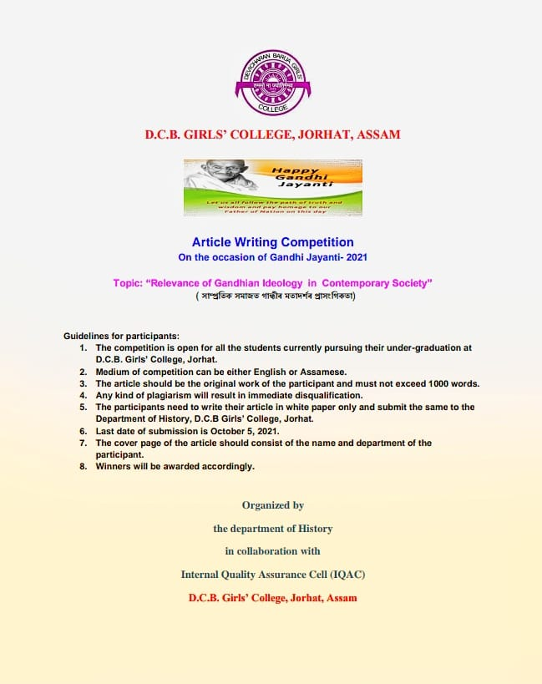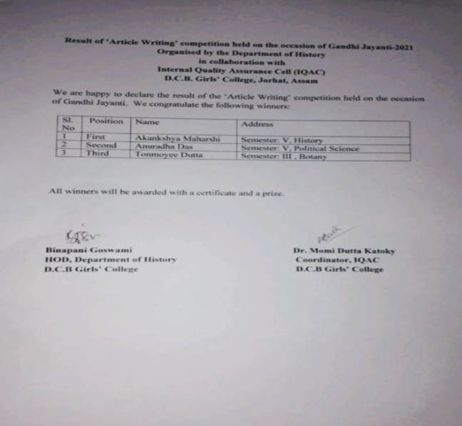
- Department of Philosophy organized ‘Quiz Competition’ on the occasion of Gandhi Jayanti on 06-10-2021.
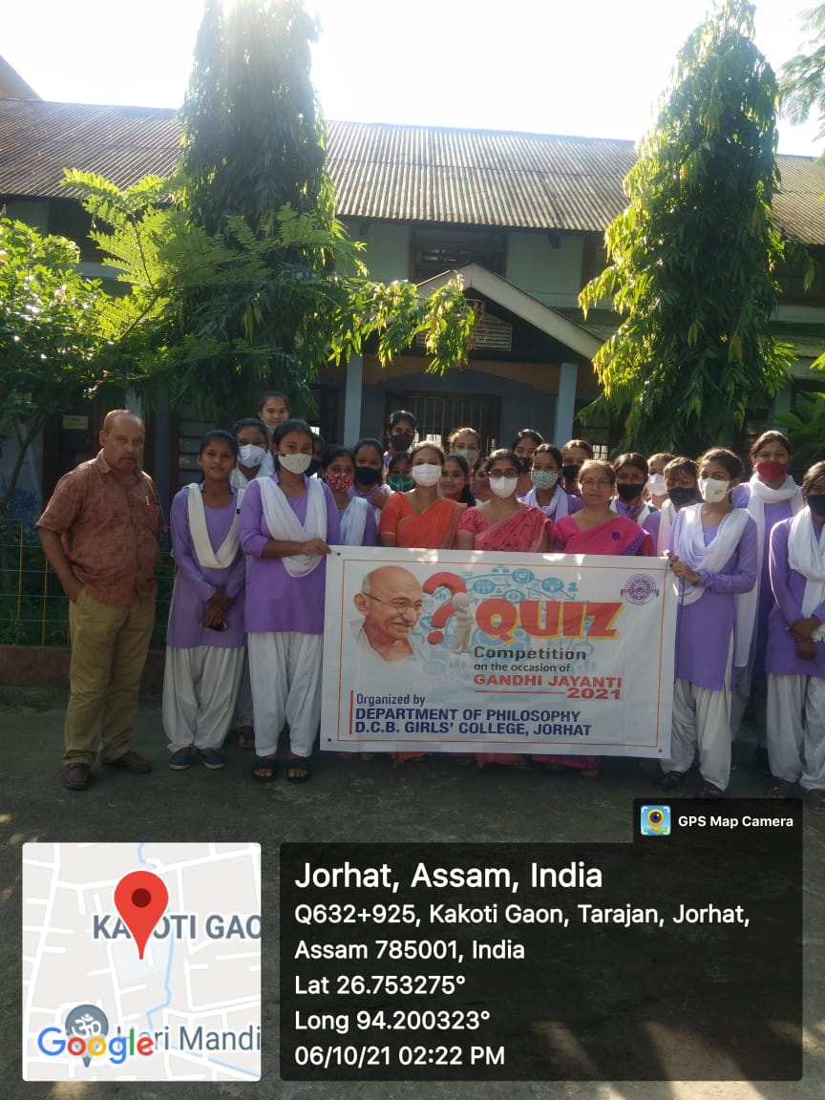

- Celebration of Azadi Ka Amrit Mahotsav : Wall Painting competition organized by NSS on 12-11-2021
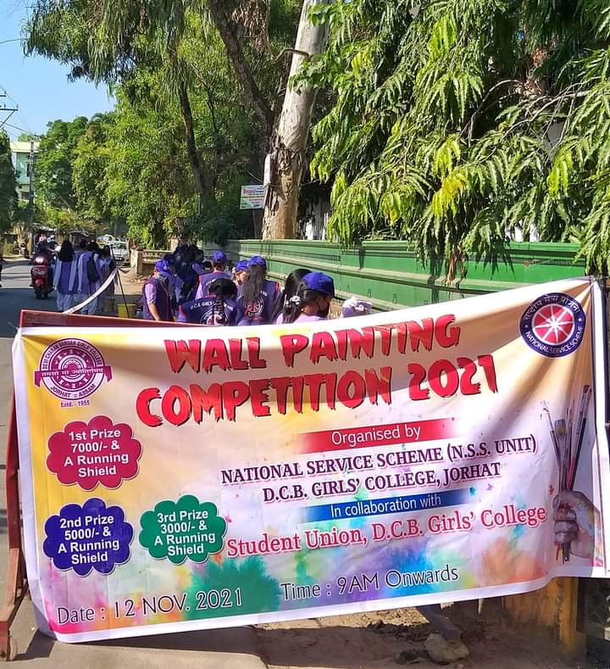

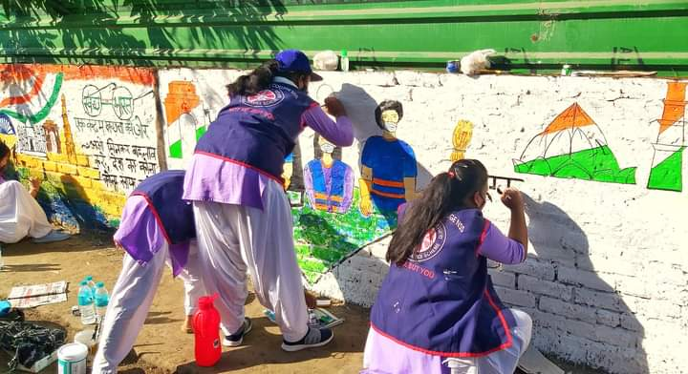

- Five day Workshop on Birds, Bio-diversity, Ecological balance from 29-11-2021 to 03-12-2021 organized by NSS in collaboration with Students Union.
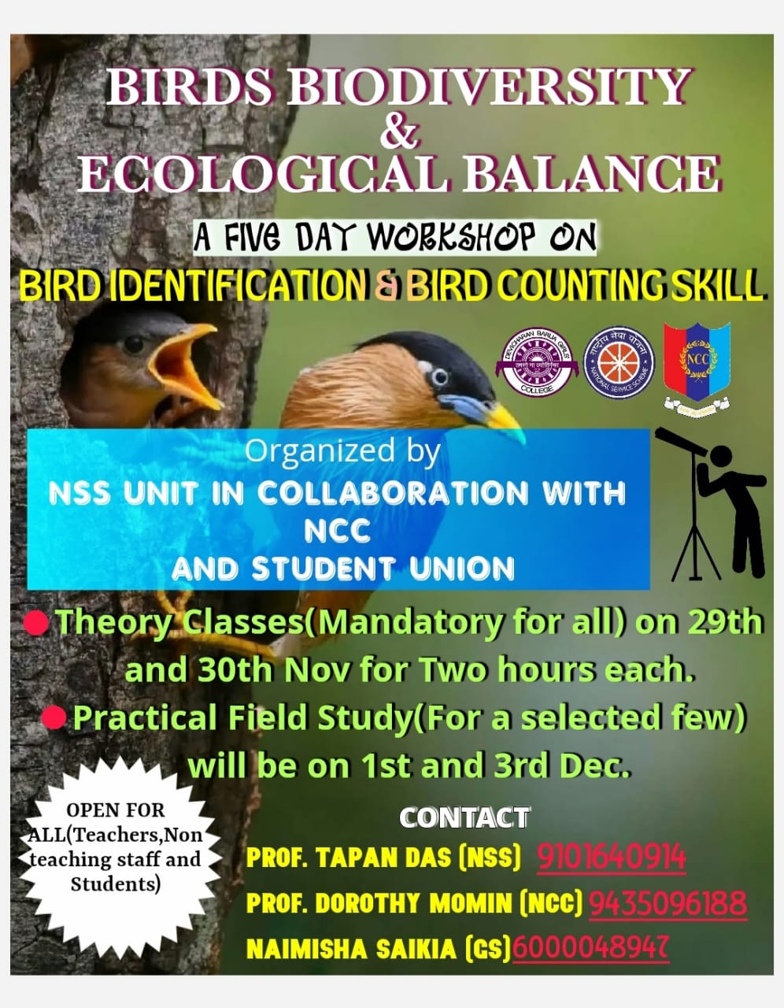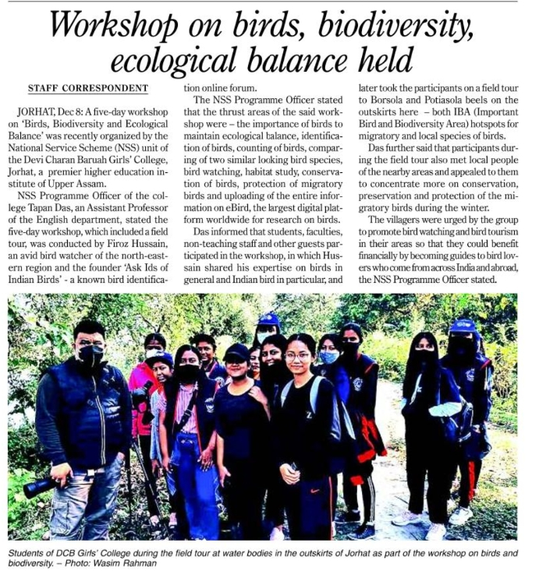

- Essay writing competition and Talent –Hunt programme organized by department of philosophy in collaboration with AIR on 06-12-2021
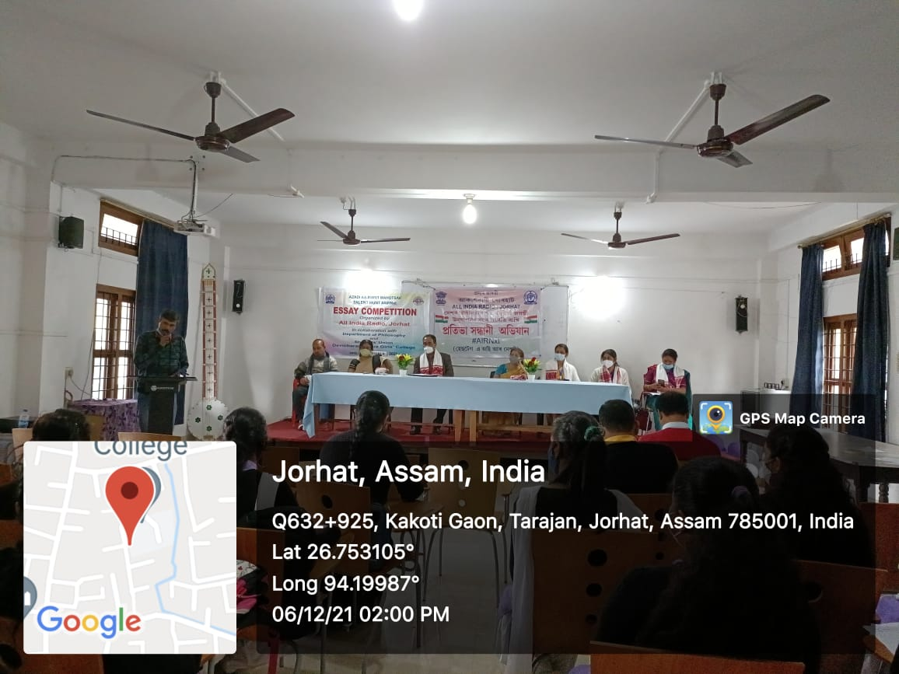
- A Seven Day Workshop on Self Defence organized by Women’s Studies Cell in collaboration with IQAC from 06-12-2021 from 12-12-2021.
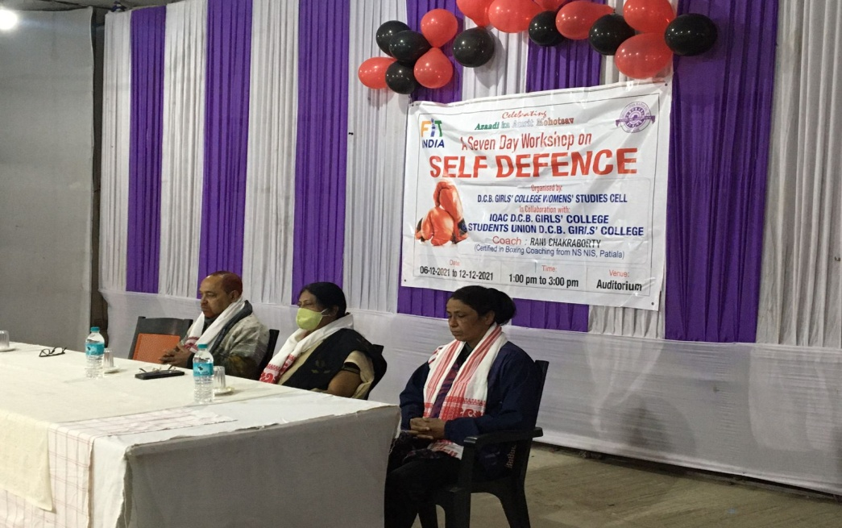
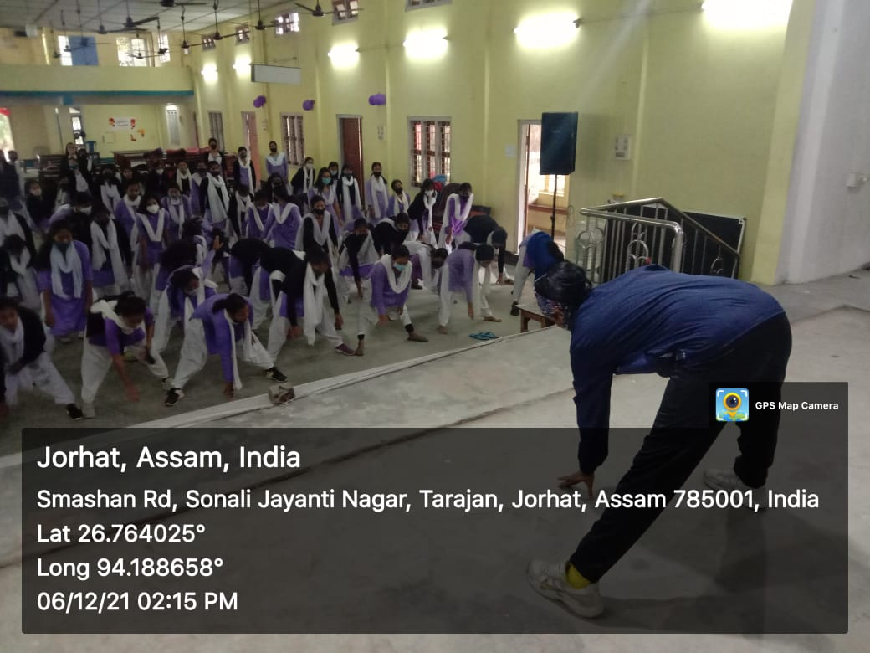

- Inauguration of Departmental Wall magazine ‘SAMIKHAN’ ,Department of Philosophy on 14-12-2021.
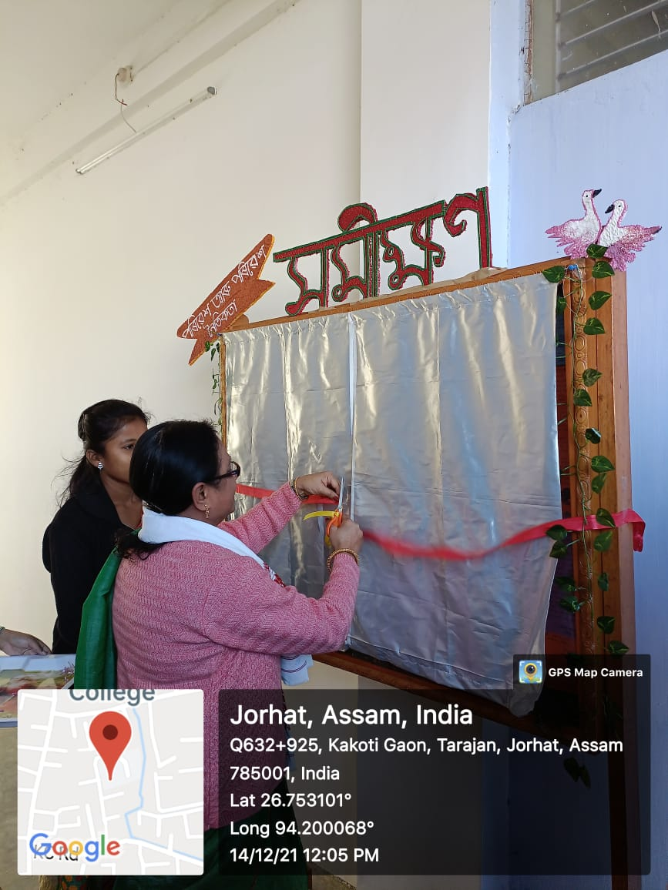

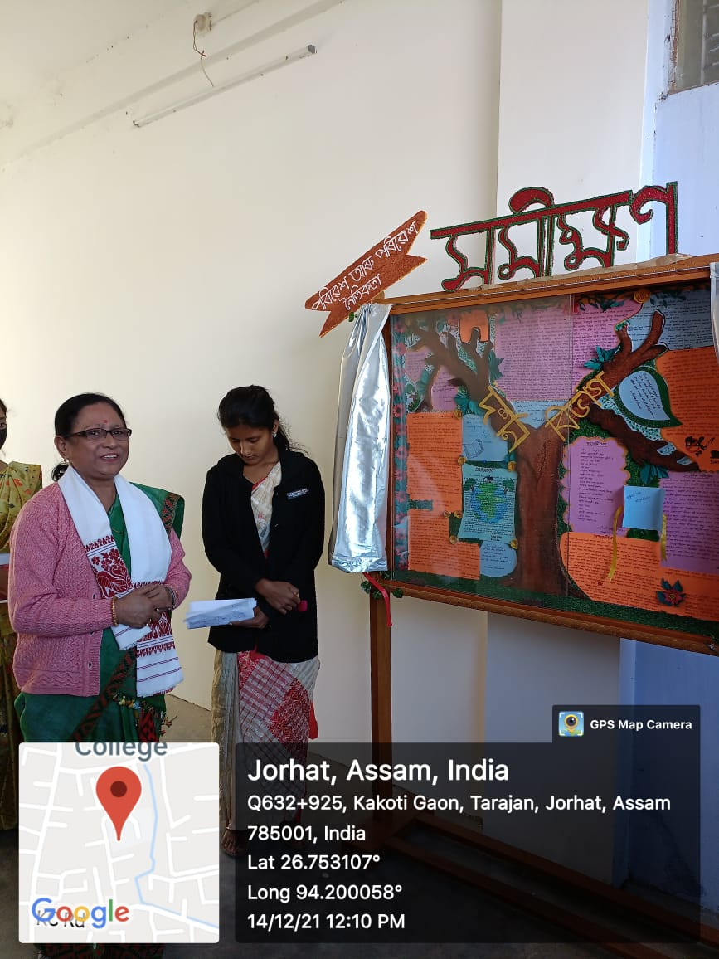

- Blood Group Detection and Science Motivation Programme: 22-12-2021
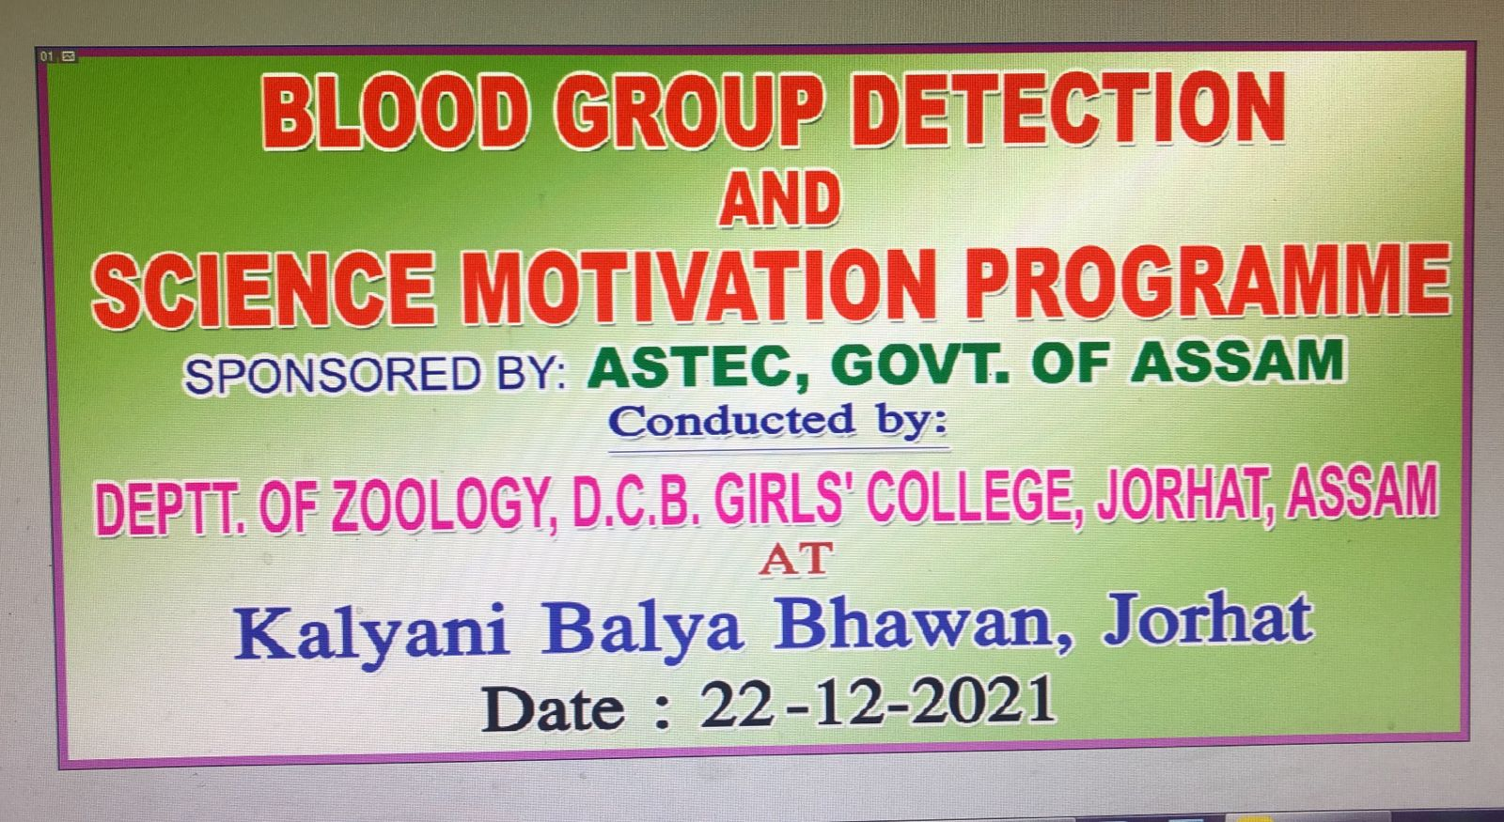
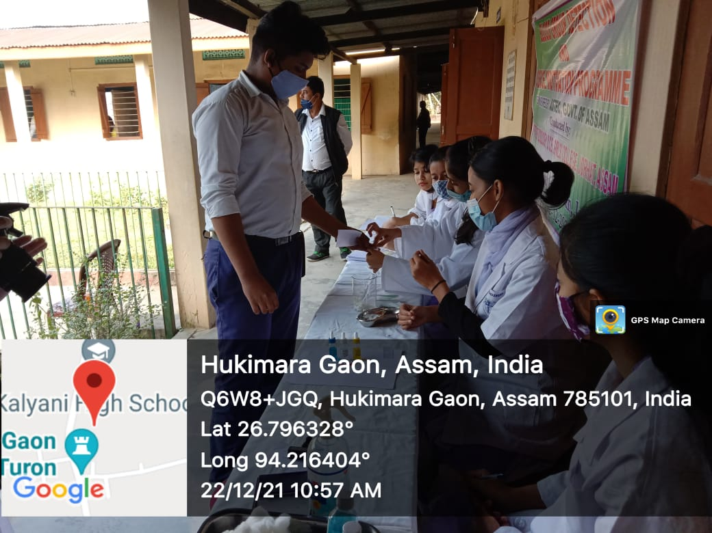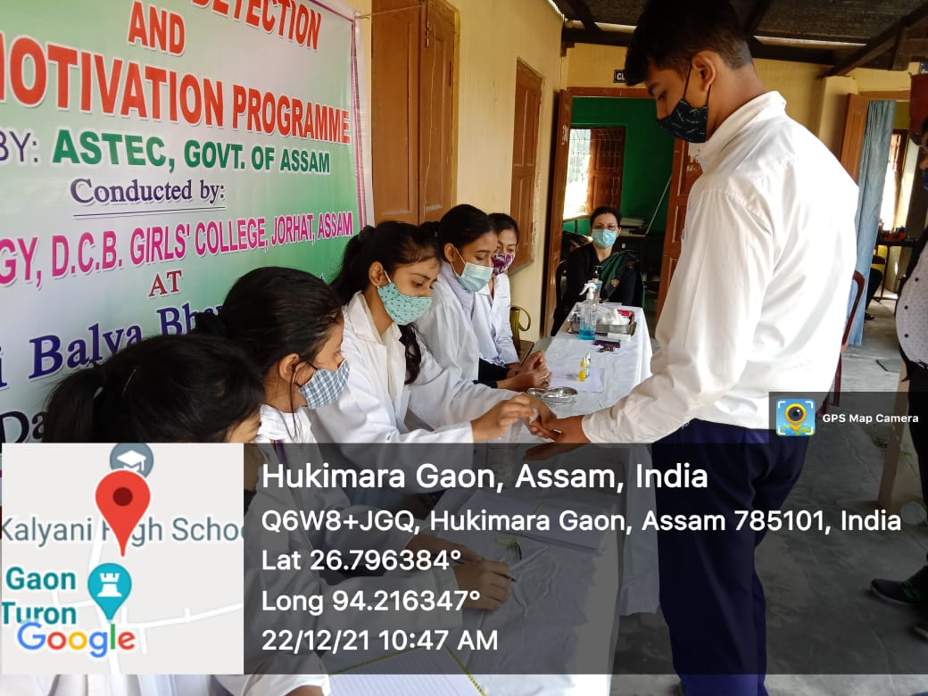

- Inauguration of Departmental Wall magazine ‘URTHITA’ ,Department of Bengali on 28-12-2021.
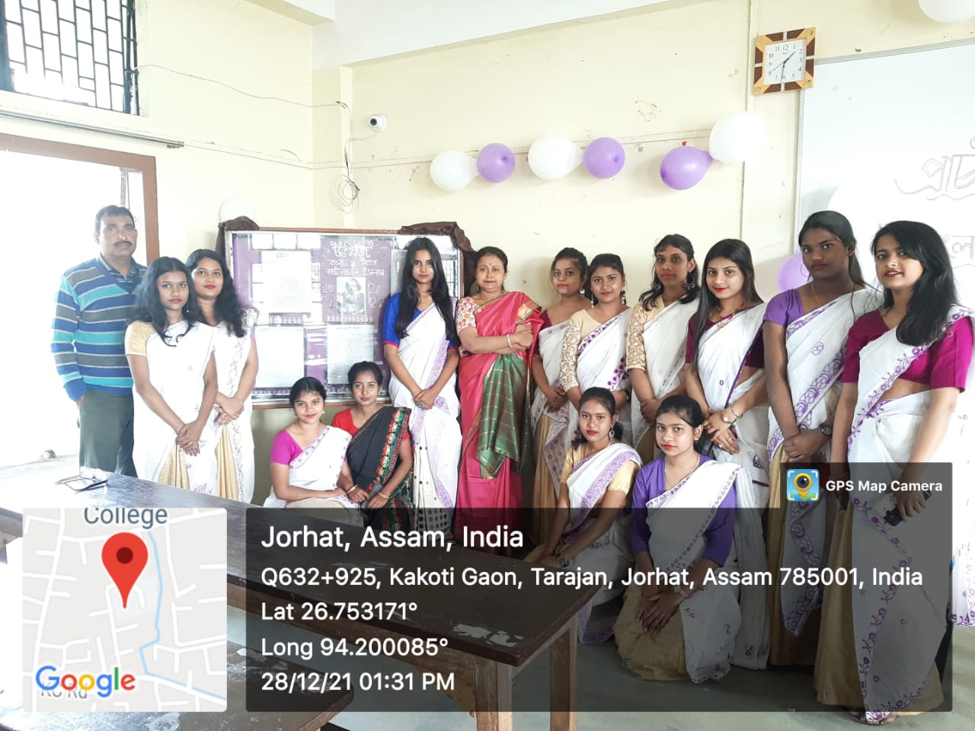

- The Yoga cell of D.C.B Girls’ College in collaboration with NCC wing organized ‘A Seven day Short –Term course on Yoga’ from 23-12-2021 to 29-12-2021.
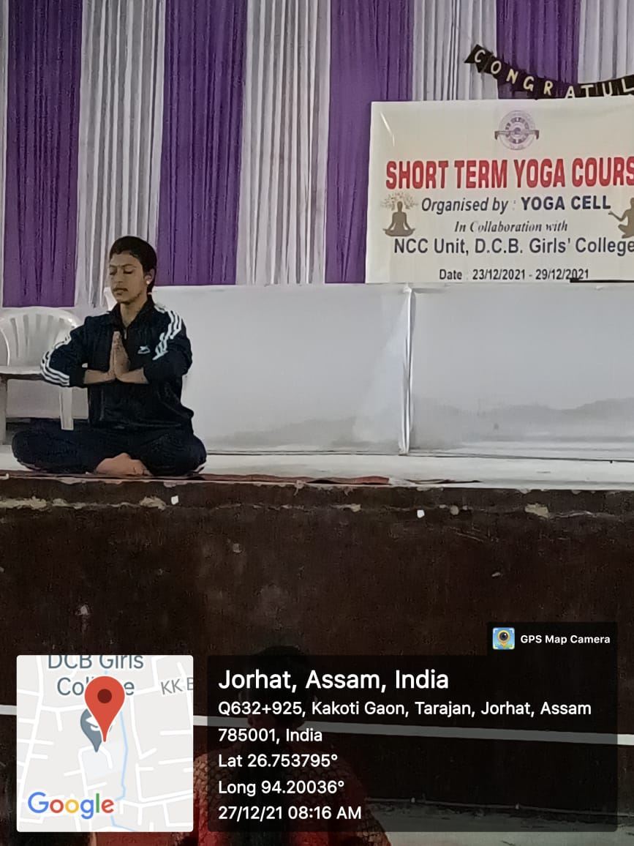

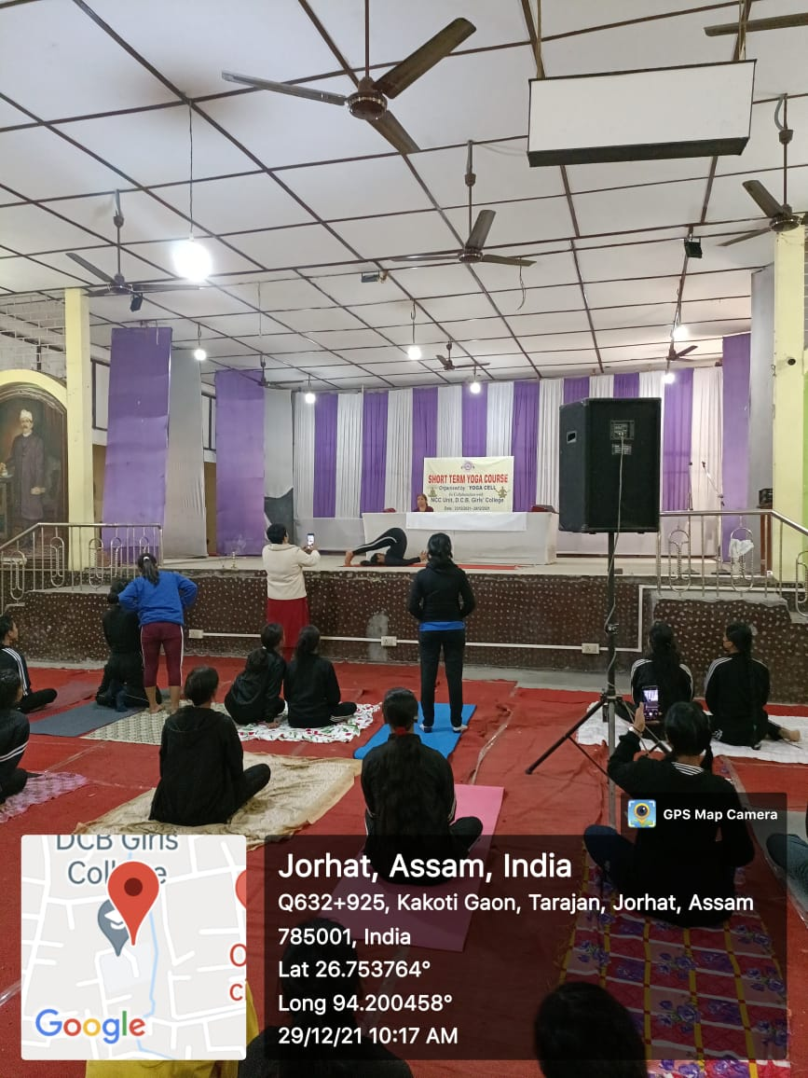

- Videography on Bio-Diversity of Maguri Motapung Bill on 03-02-2022 Prepared by Department of Geography
Link for You Tube Video-https://youtu.be/eLf-ZqOyuRc

- Three Day workshop on Innovation and Entrepreneurship from 29-05-2022 to 31-05-2022 organized by NSS in association with IQAC, Career Counselling Cell and Kaziranga University, Jorhat.
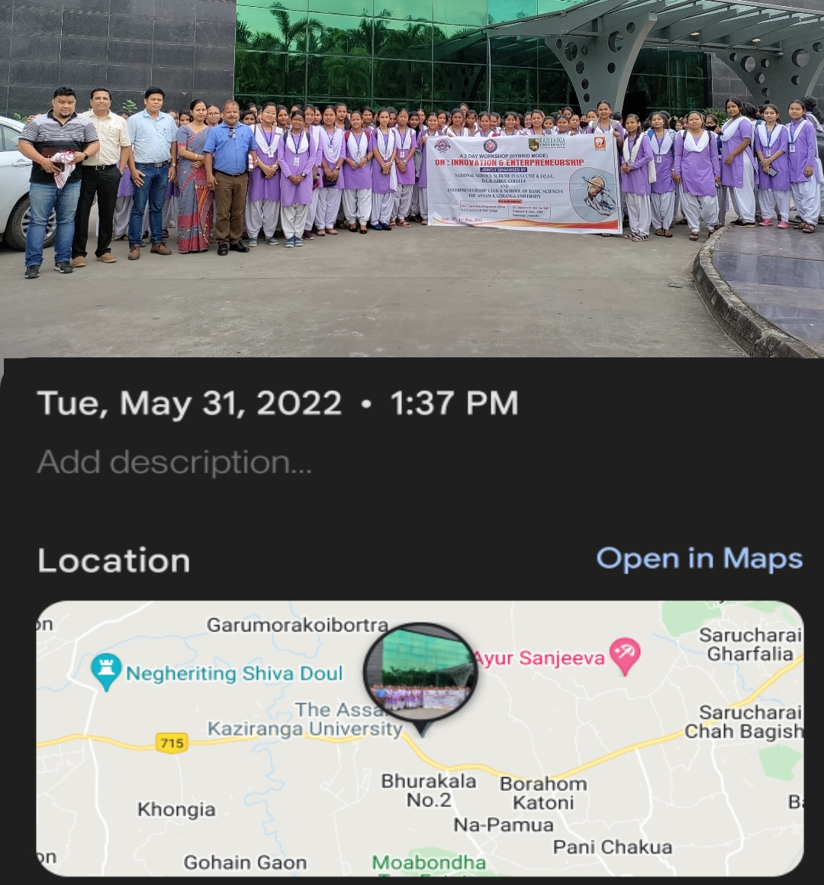
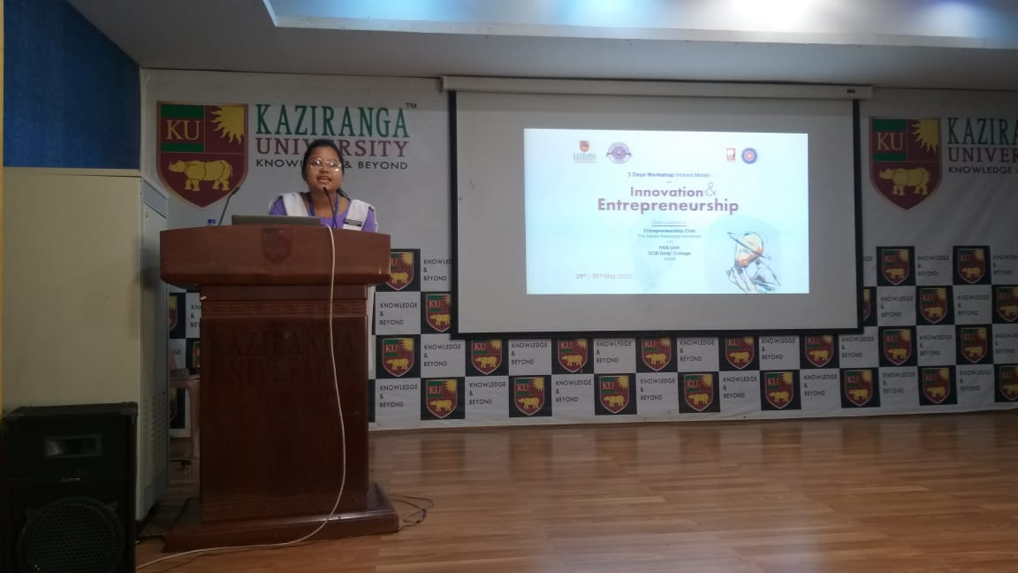
- Orientation Programme on Personality Development on 28-05-2022 organized by Career Counseling Cell in association with Royal Global University.
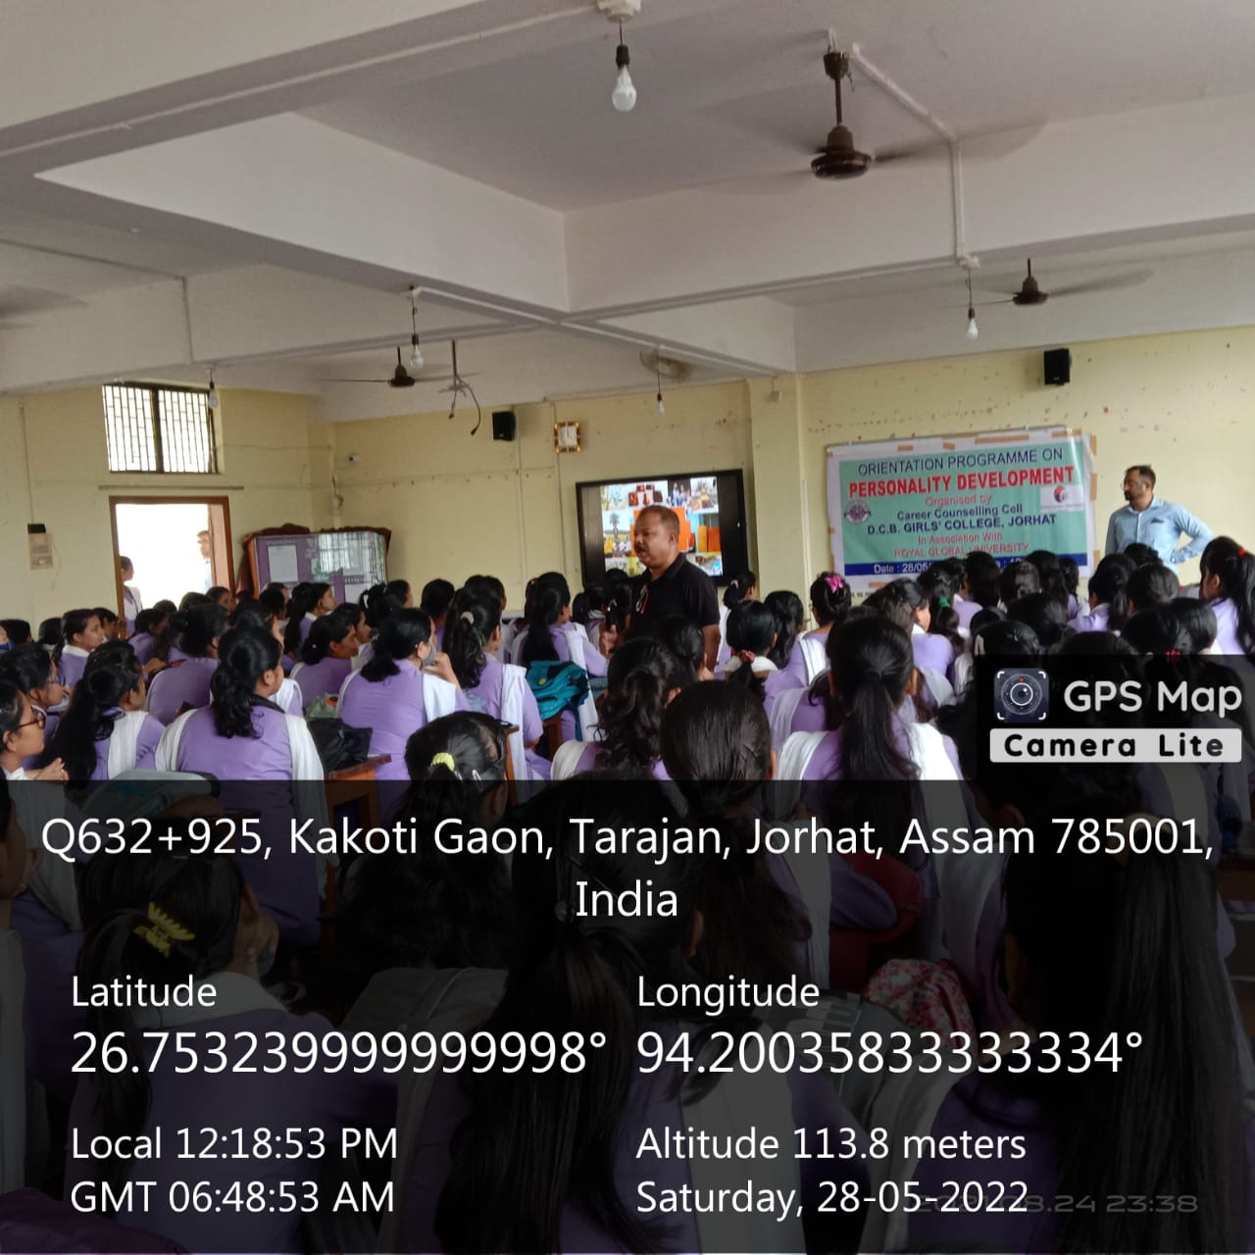

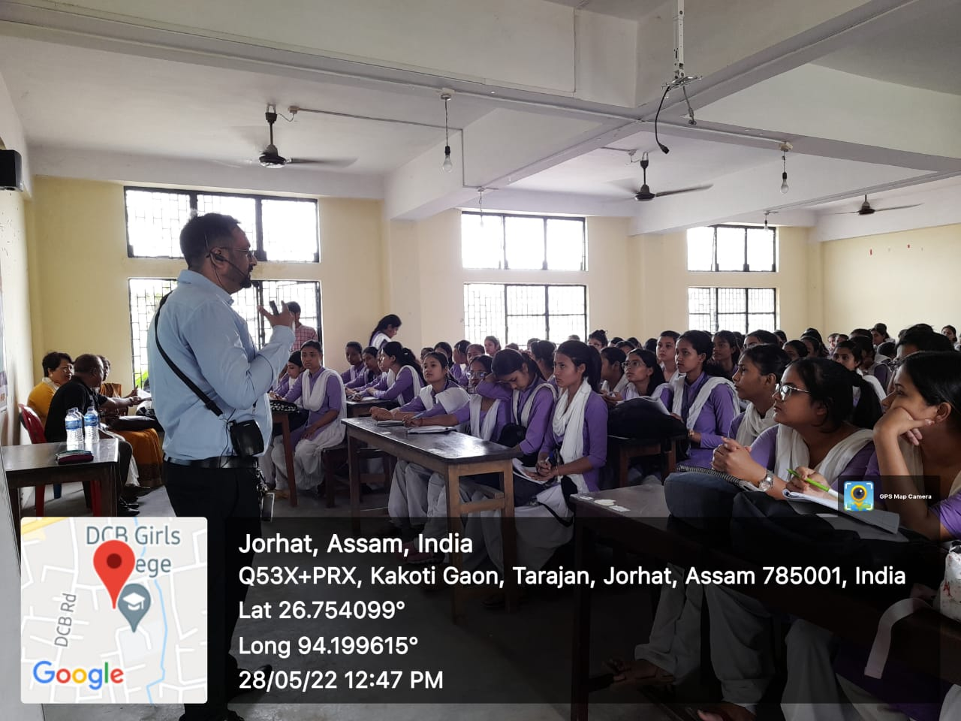

- Training programme on How to Prepare for APSC Examination on 02-06-2022 organized by Career Counselling Cell in association with Career Choice, Jorhat.
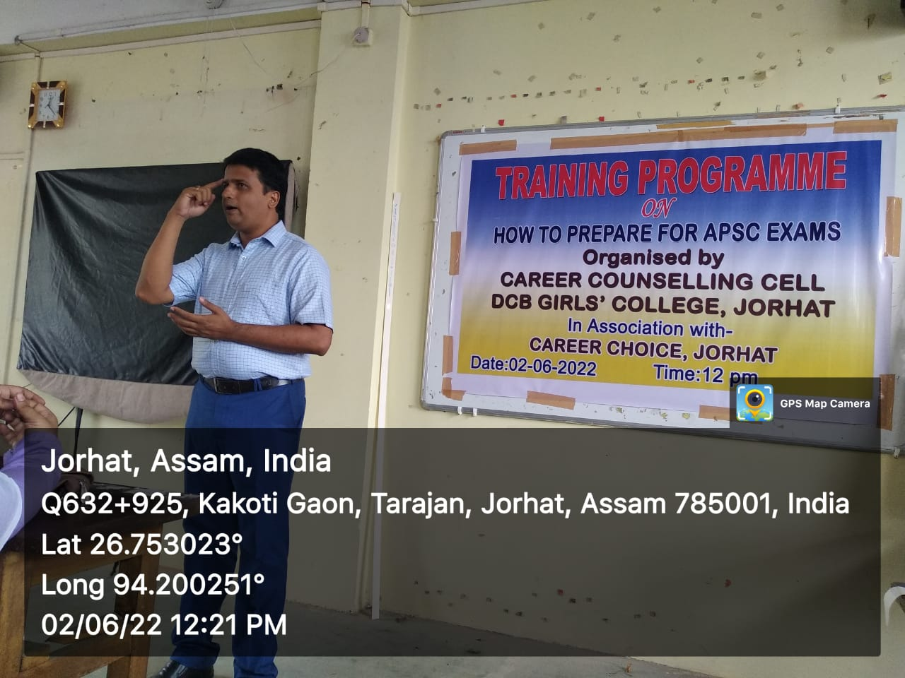

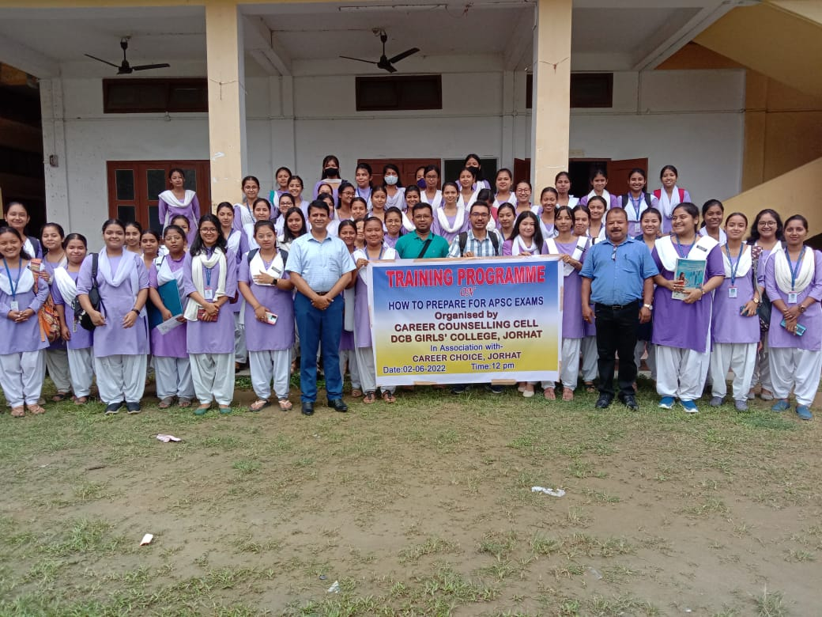

- One week Workshop on How to prepare for PG Entrance Examination from 16-06-2022 to 22-06-2022 organized by Department of Geography

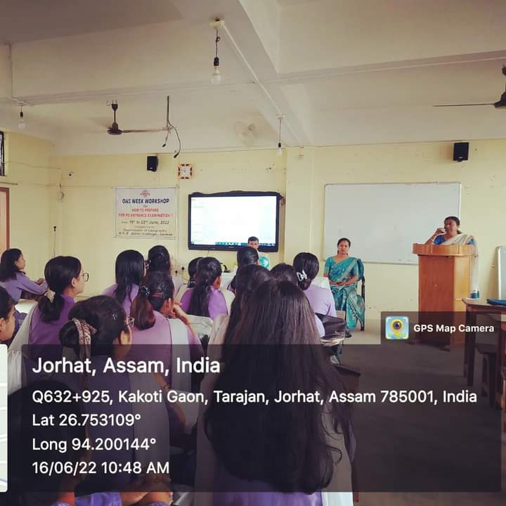

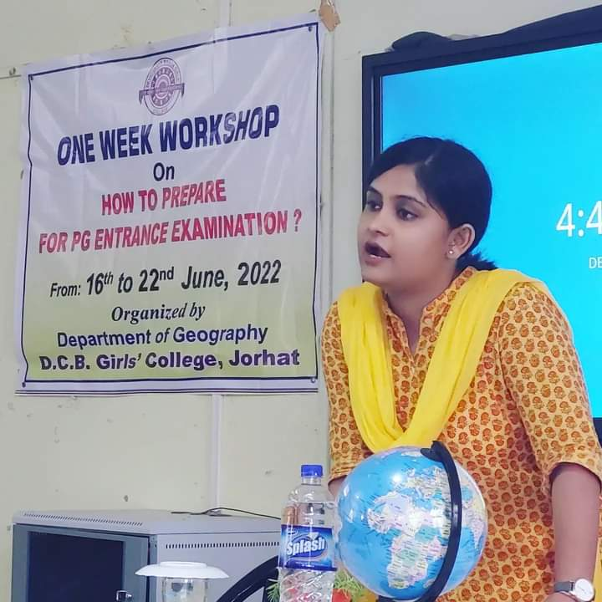

- Three Day Workshop on Yoga organized by N.S.S,N.C.C wing and Yoga Cell of D.C.B. Girls’ College from 19-06-2022 to 21-06-2022

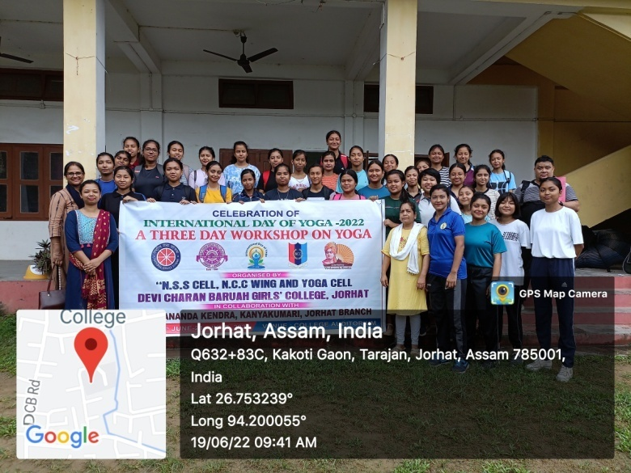

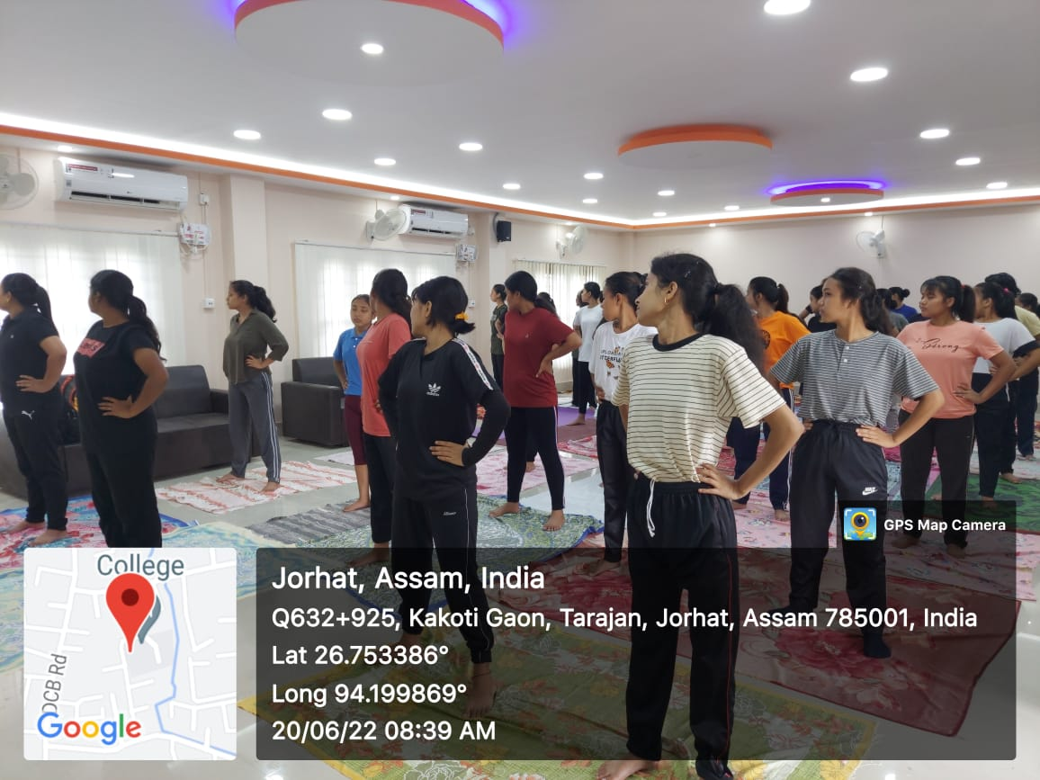

- Interdepartmental Patriotic song competition organized by Women’s Studies Cell, D.C.B Girls’ College on 17-08-2022
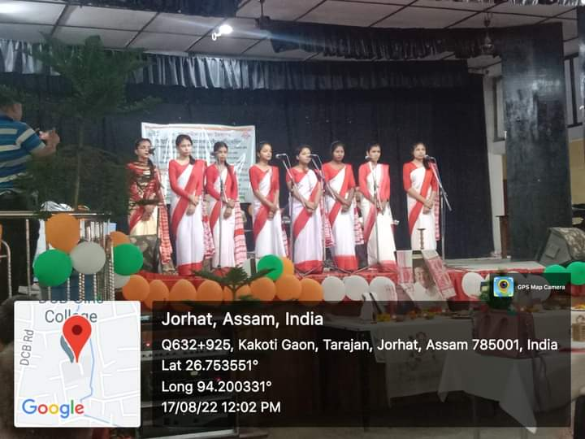

- Add on Certificate Courses for skill Development:
From the academic session 2022-2023 the following University approved skill development courses have been introduced:
- Yoga for Physical and Mental Health
- Add on Certificate Course on Soft Skill Development
- Add on Certificate course on Digital Cartography
- Add on Certificate course on Vermicomposting
- Add on Certificate course on Wild Life photography and Science communication
- Certificate course on Information Technology
- Add on Certificate course on Tourism and Travel management
- Add on Certificate course on Recitation
- Add on Certificate course on Entrepreneurship Development

